**PRACTICAL- 10**

**AIM:-**The study construction and execution of PCM and PCM-TDM signals using Transmission and Reciever kit.

**APPARATUS:-**

1.OSCILLOSCOPE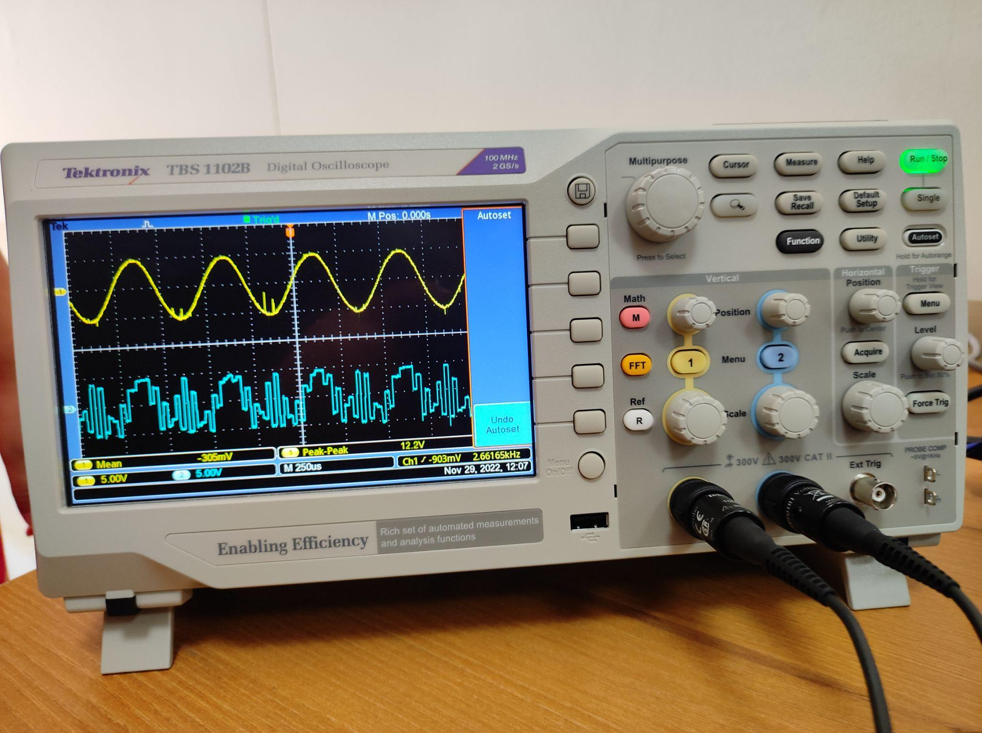

2. PCM-TDM TRANSMITTER:-

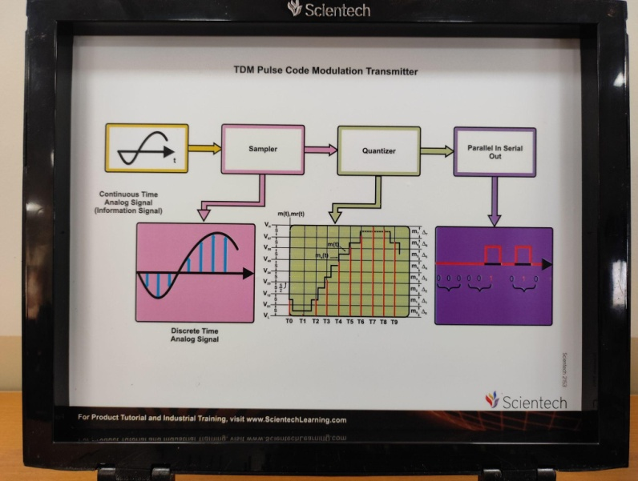 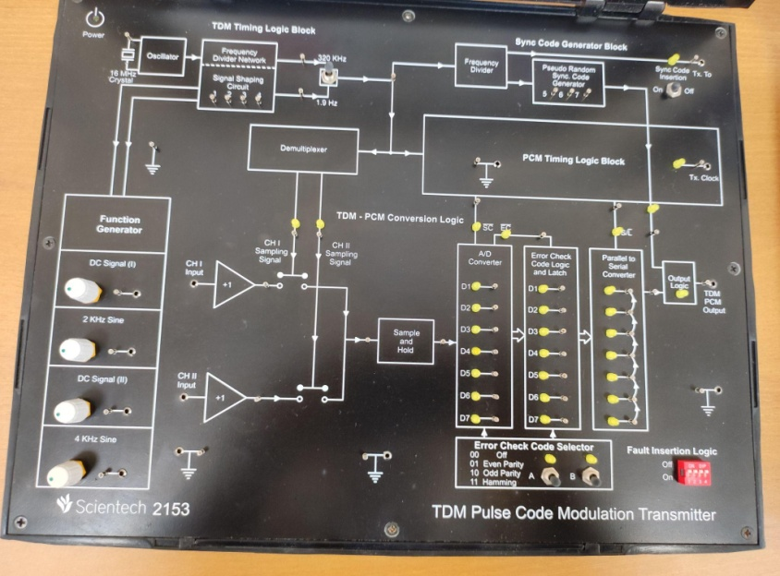

3.TDM DECODER and DEMODULATOR KIT:-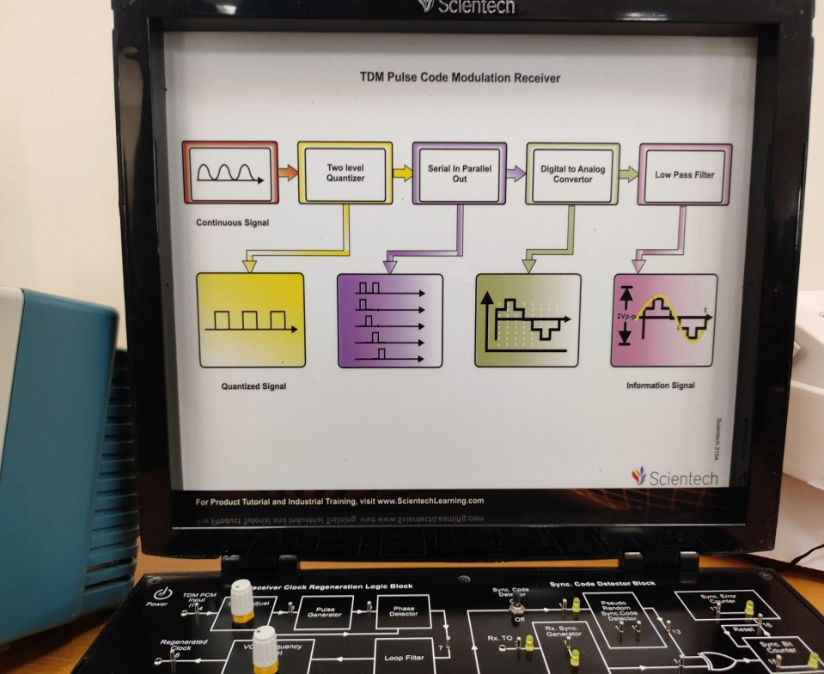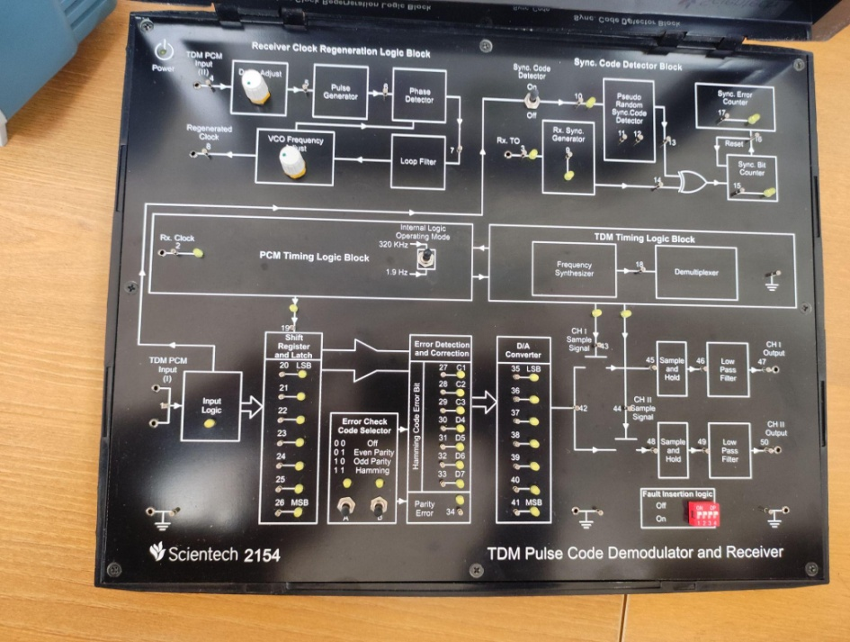

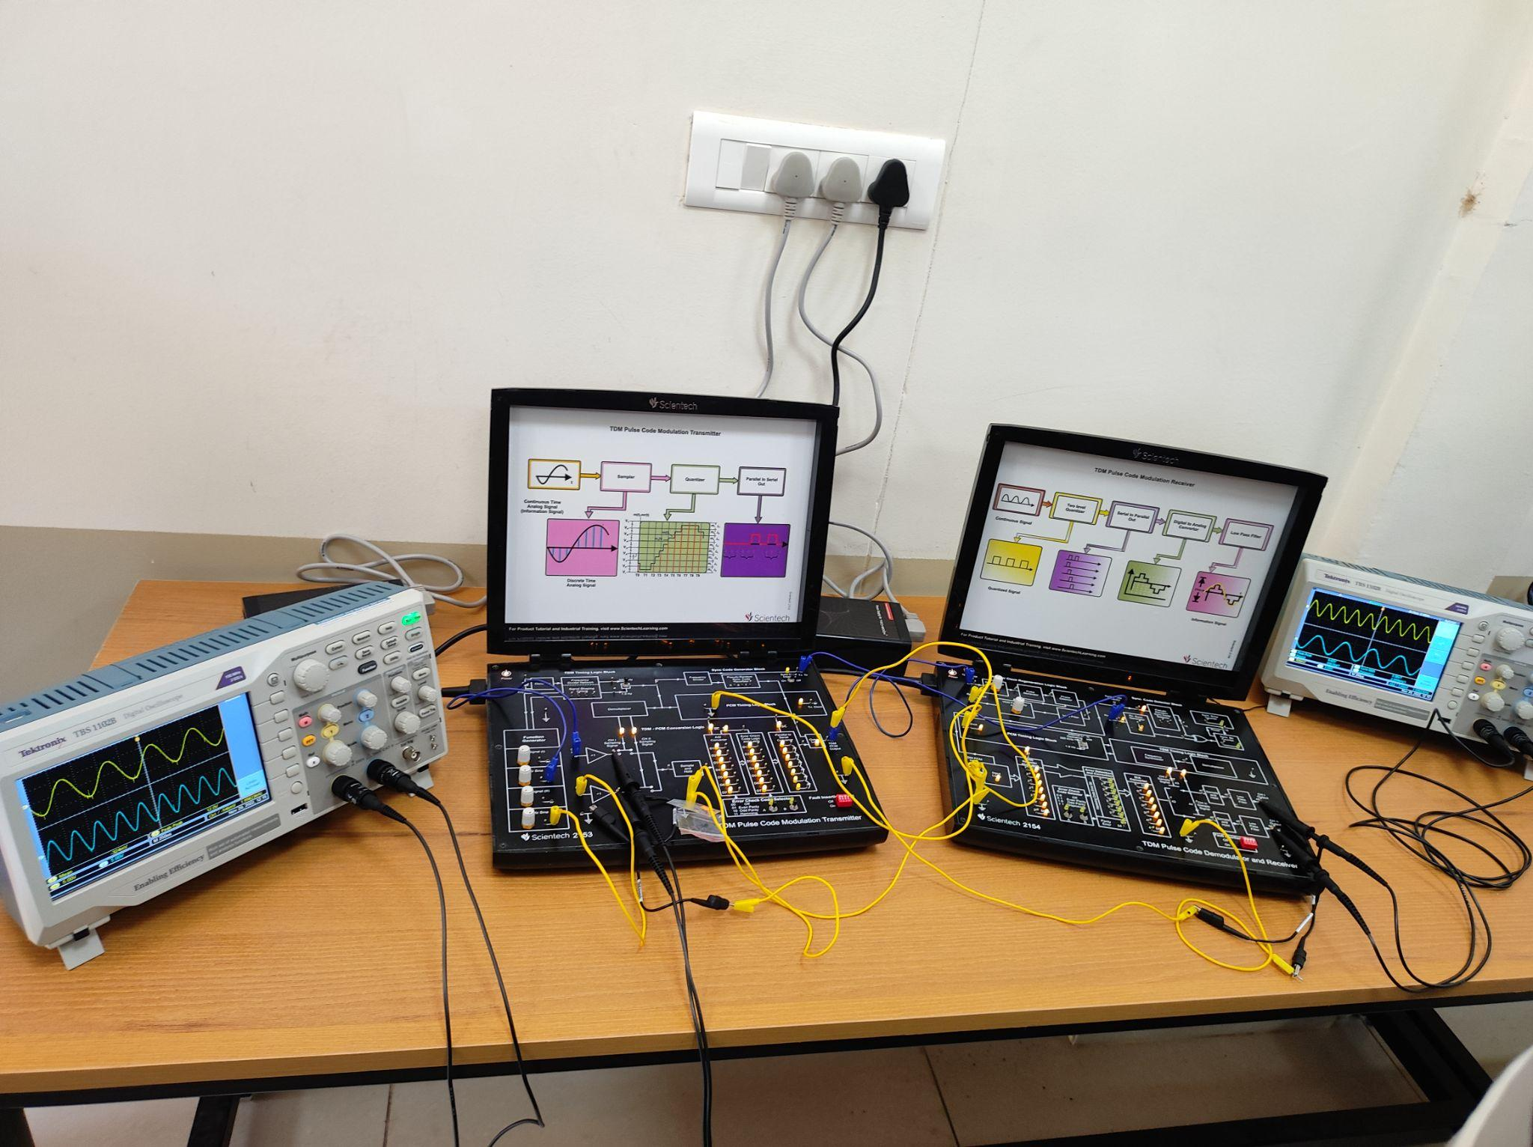

**OBSERVATION: (PCM TX –RX)**

MESSAGE Signal(2KHz) and its SAMPLED OUTPUT Signal:-

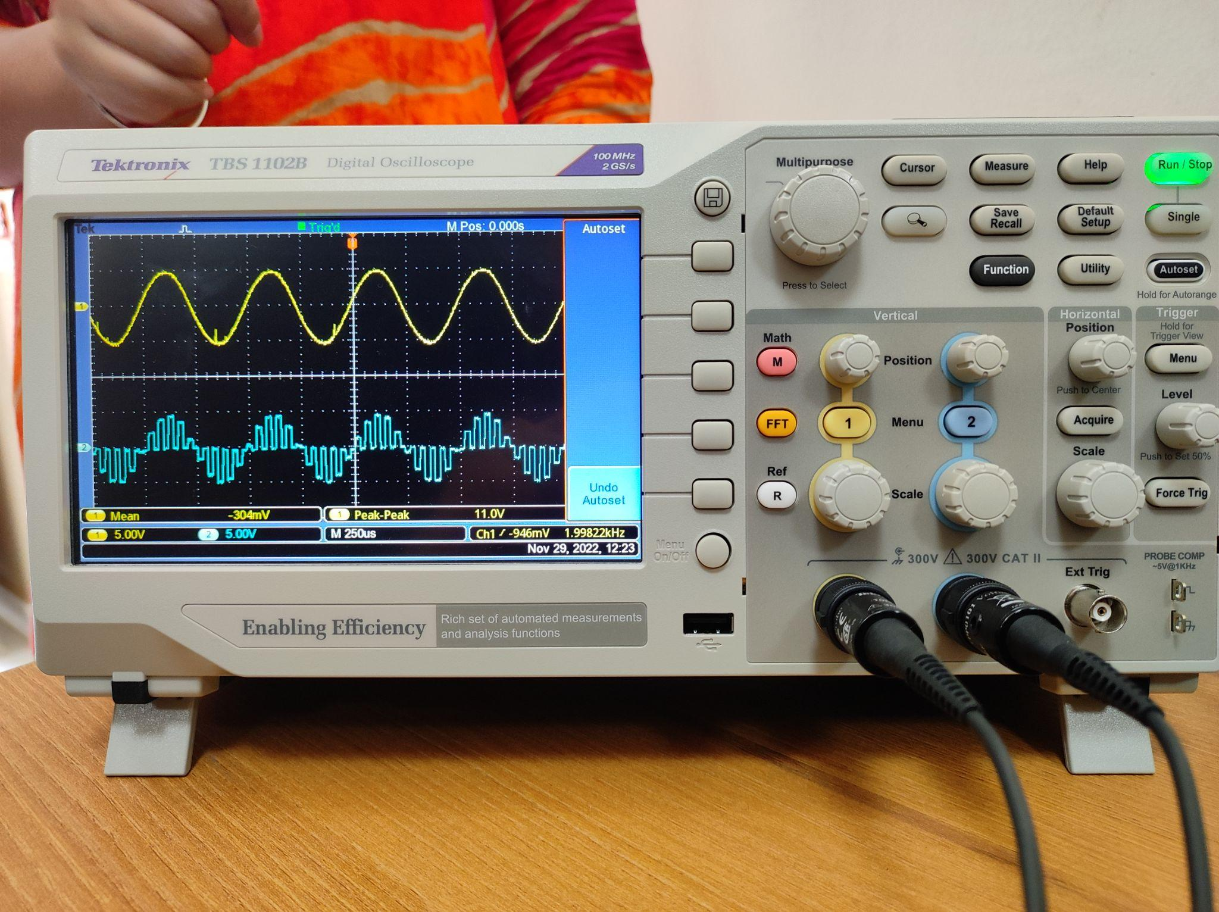

RECONSTRUCTED Signal and RECIEVED PCM Signal:-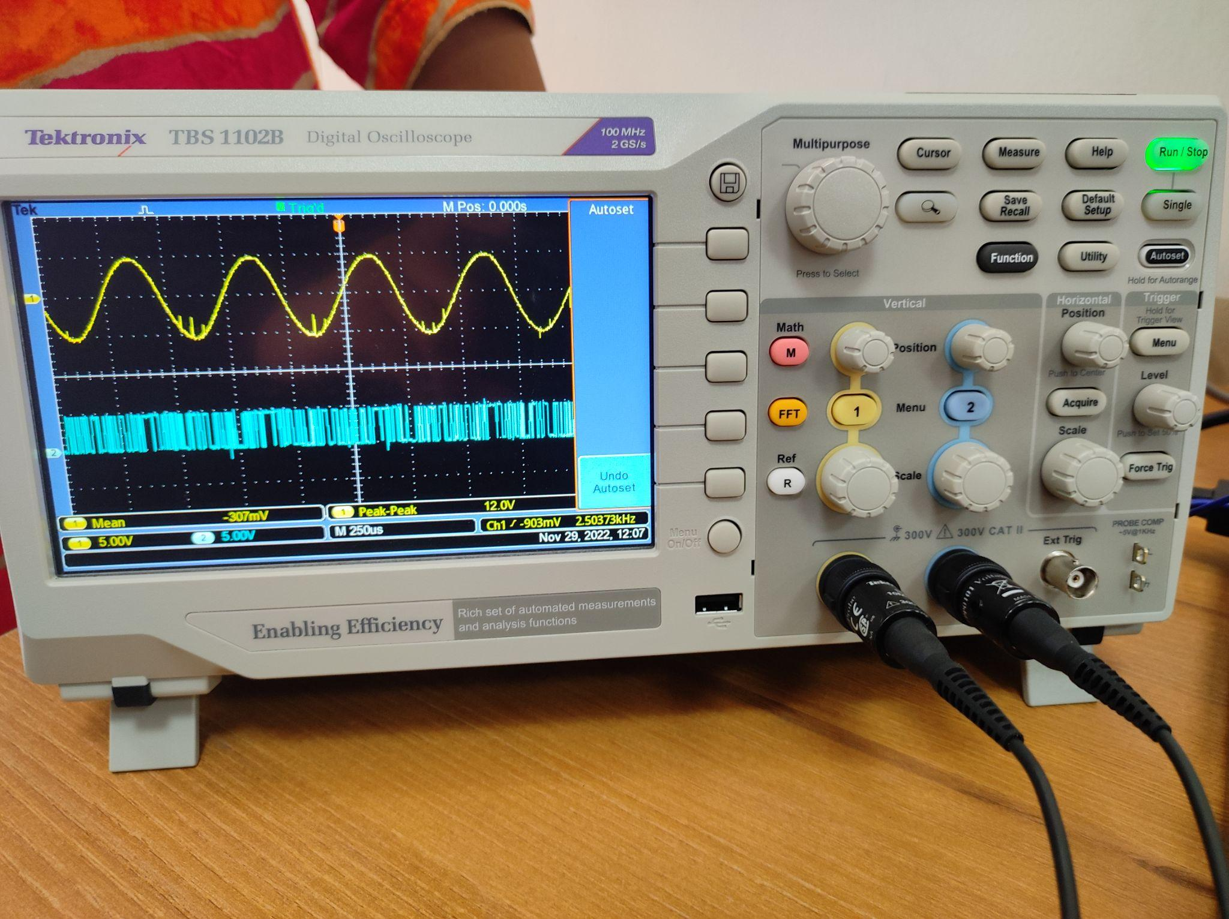

**OBSERVATION: (PCM-TDM TX –RX)**

TWO MESSAGE SIGNAL (2KHz and 4KHz):-

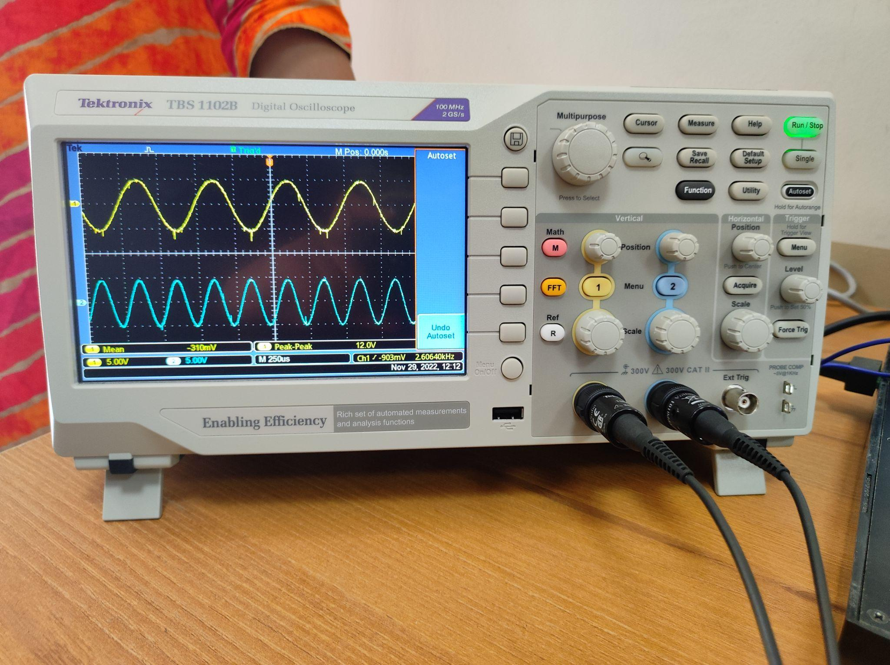

TDM SAMPLED SIGNAL for both the SIGNALS (2KHz&4KHz):-



PCM Signal and RECONSTRUCTED Signal:-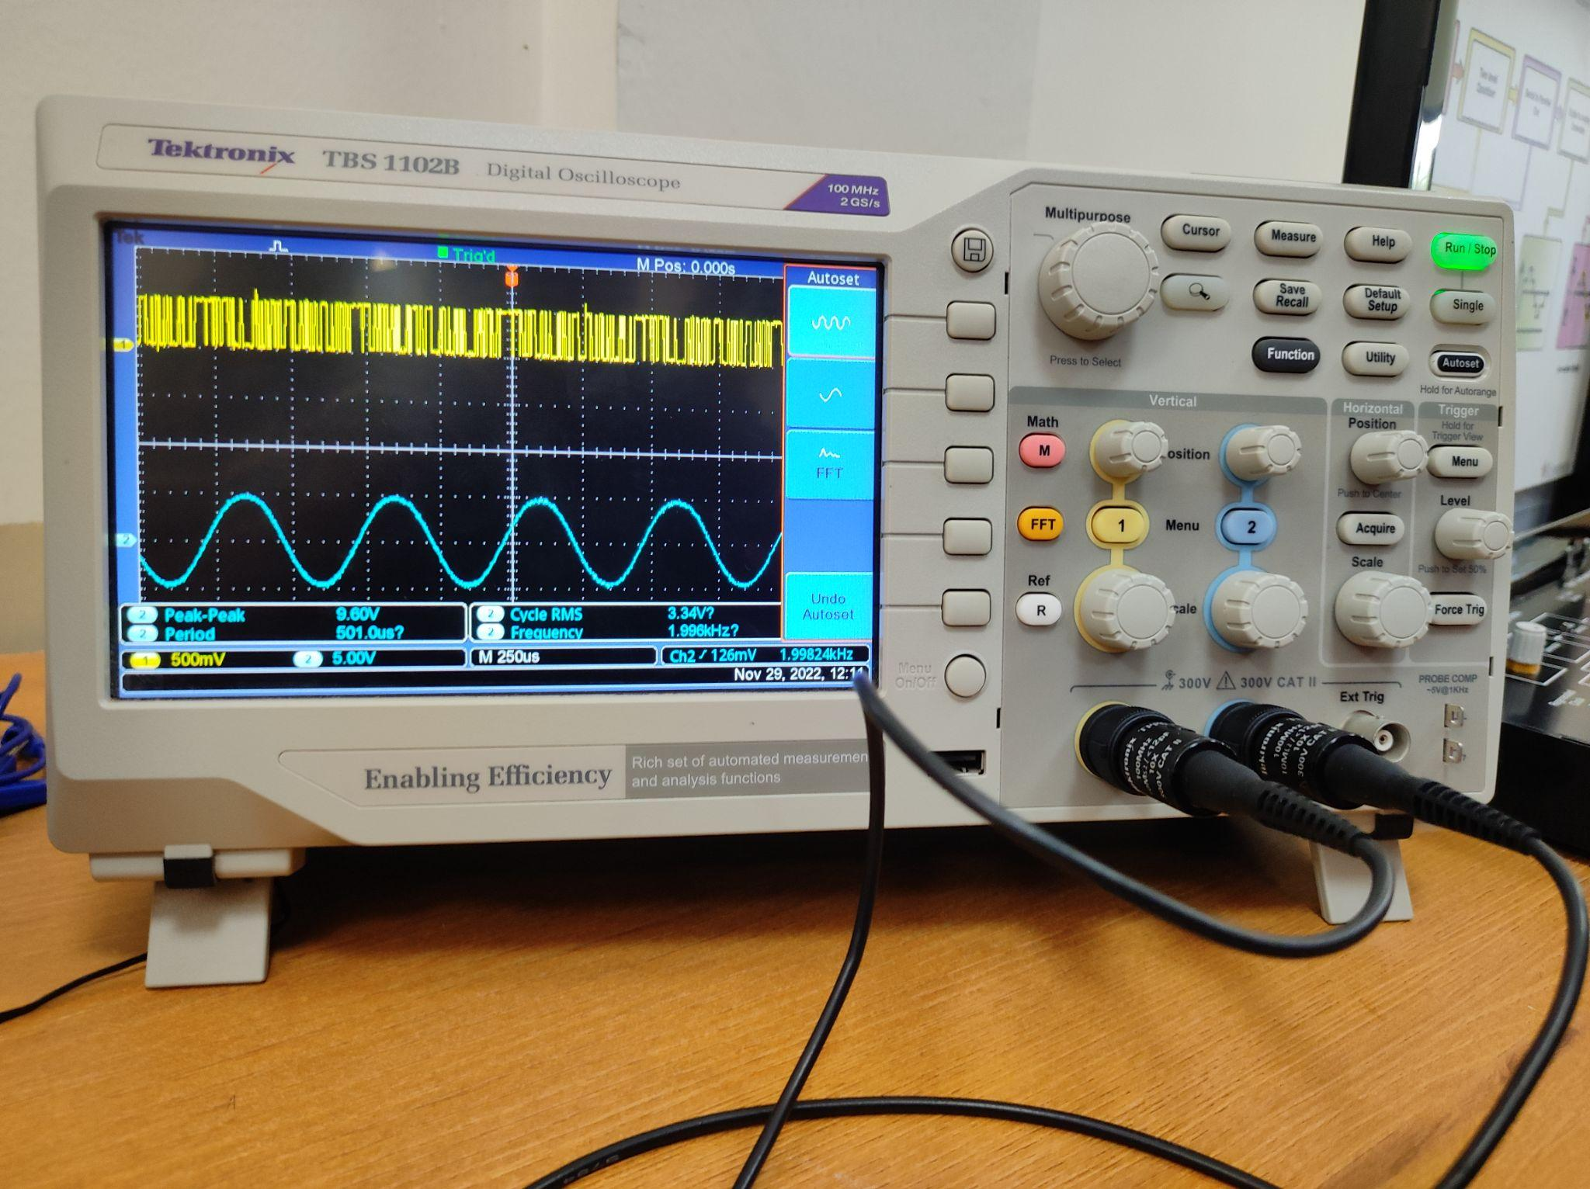

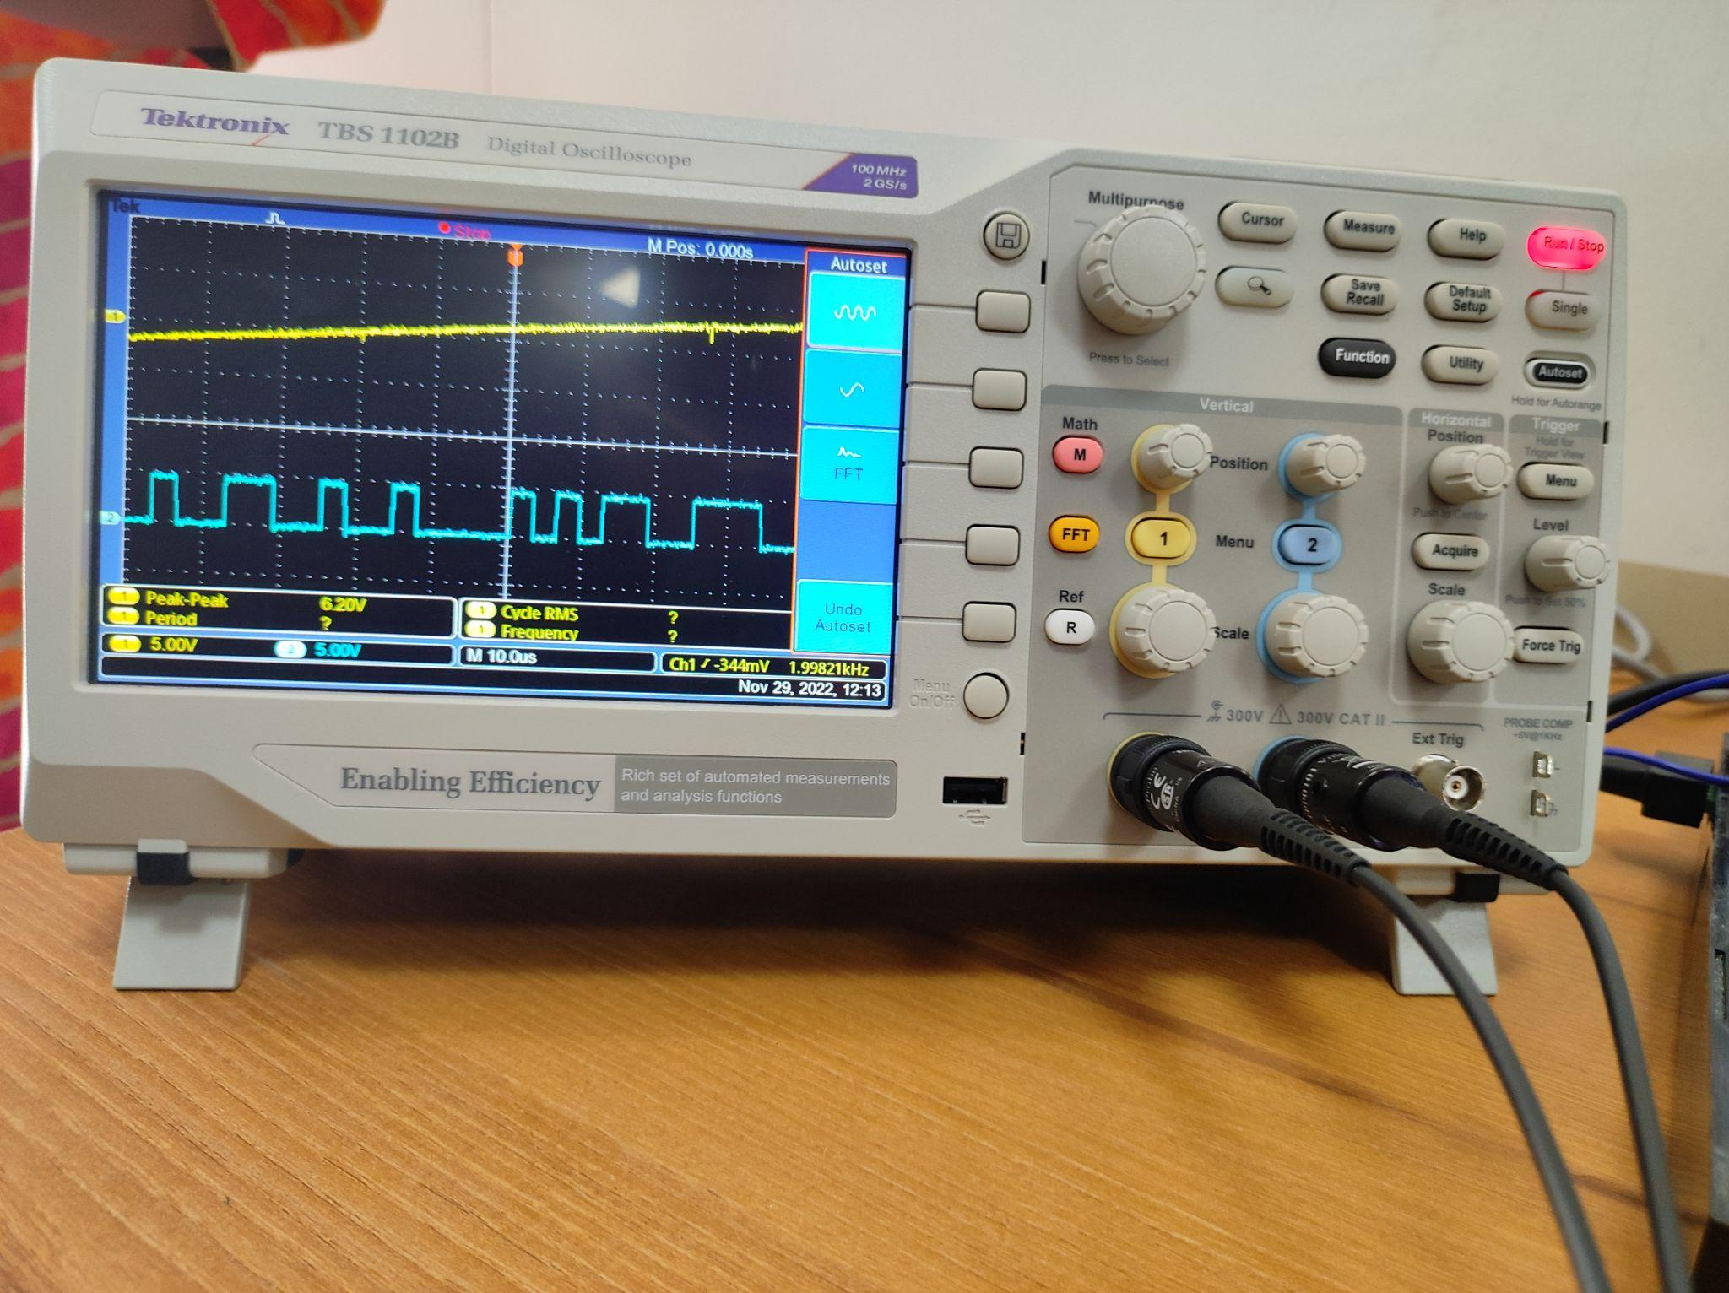

TDM RECONSTRUCTED SIGNAL (2KHz and 4KHz):-

**CONCLUSION:-**

We learned how to createe ,transmit and recieve PCM,PCM-TDM signaal using TDM Transmission and Recieving Kit.